**SenseTime**

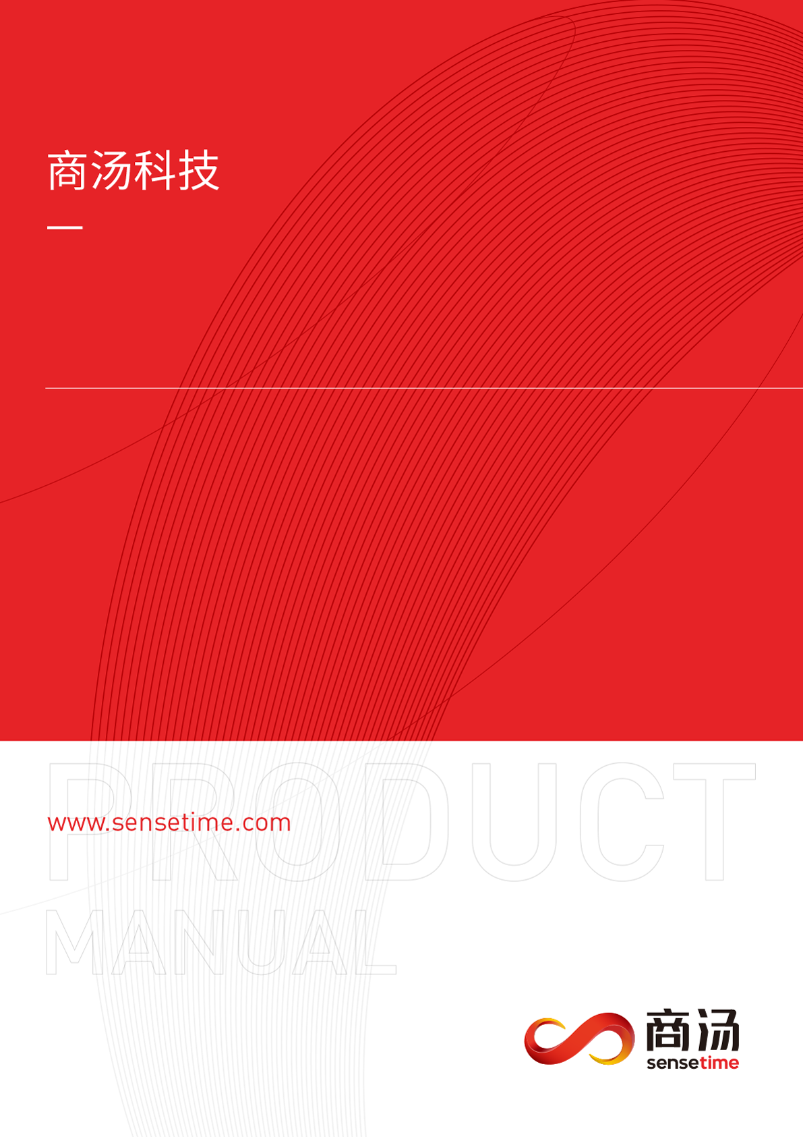

**SenseStorm User Manual 2.0**

**(English Version)**

**Directory**

**1. Getting to Know SenseStorm**

* 1. List of Items
  2. Product Regulations

**2. How to Safely Operate SenseStorm**

**3. Instruction Guidelines**

* 1. Software Installation
  2. Battery Installation and Charging
  3. Accessories

3.3.1 Connecting and Usage of Sensors

3.3.2 Motor Control

3.3.3 Acoustics Control

* 1. Switching Modes
     1. Introduction of Function Modes
     2. Teaching Mode
     3. Ball Tracking Mode
     4. Gesture Recognition Mode
     5. Face Detection (AI Smart Fan) Mode
  2. Button Operation and LED indicator
     1. Button Operation Correspondence Table

**4. How to Clean SenseStorm**

**5. Common Errors and FAQ**

**1. Getting to Know SenseStorm**

1.1 List of Items

* Main Control Board ×1
* Battery ×1
* Power Charging Cable ×1
* Ultrasonic Sensor ×1
* Color Sensor ×1
* Speaker ×1
* Speaker Charging Cable ×1
* Audio Cable ×1
* Camera ×1
* Instruction Manual ×1
* TF card ×1

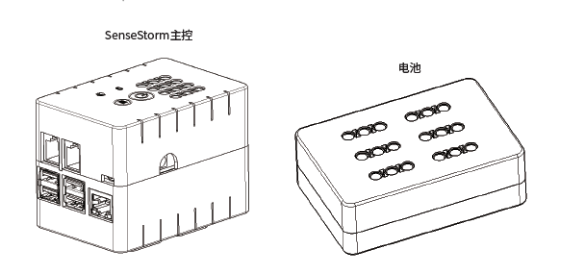

Battery

Main Control Board

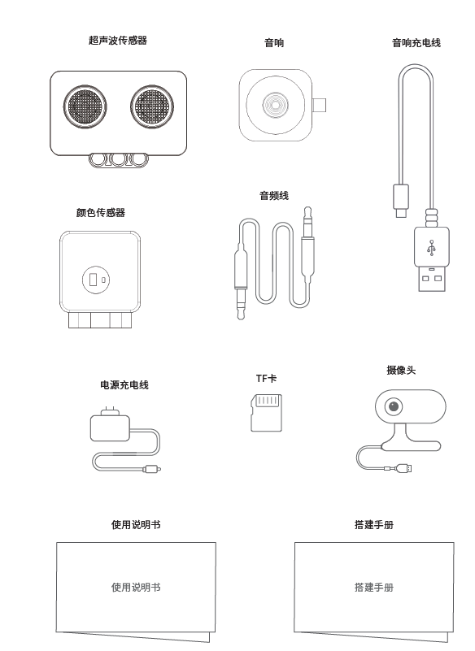

Instruction Manual

Instruction Manual

Camera

TF Cable

Power Charging Cable

Color Sensor

Audio Cable

Speaker Charging Cable

Speaker

Ultrasonic Sensor

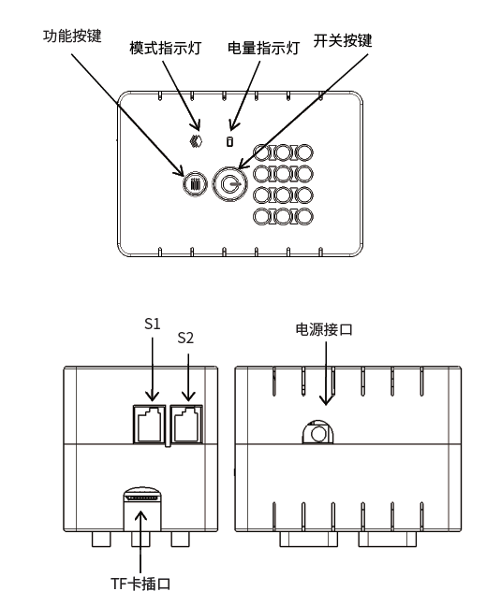

TF Card Port

Battery Port

Mode Indicator

Function Button

Battery Level Indicator

On/Off Button

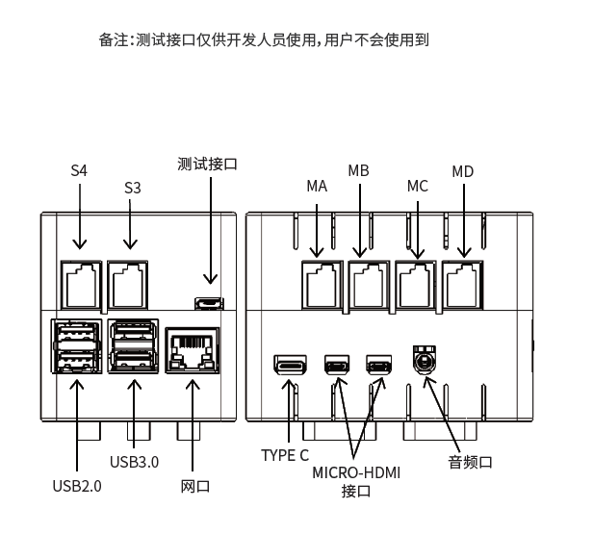

Testing Port

Audio Port

Port

Network Port

Testing Port is only reserved for developers to use.

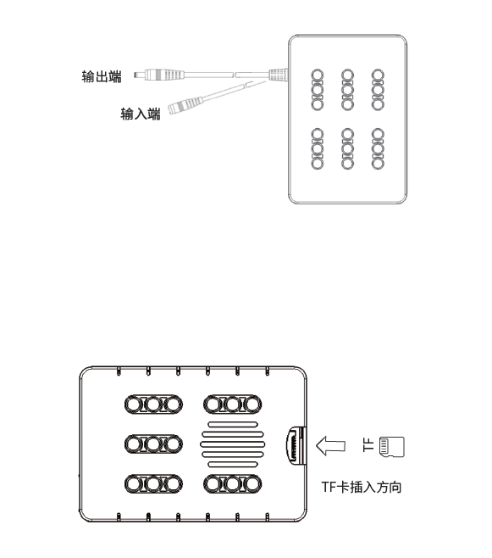

Direction for TF Card Insertion

Input

Output

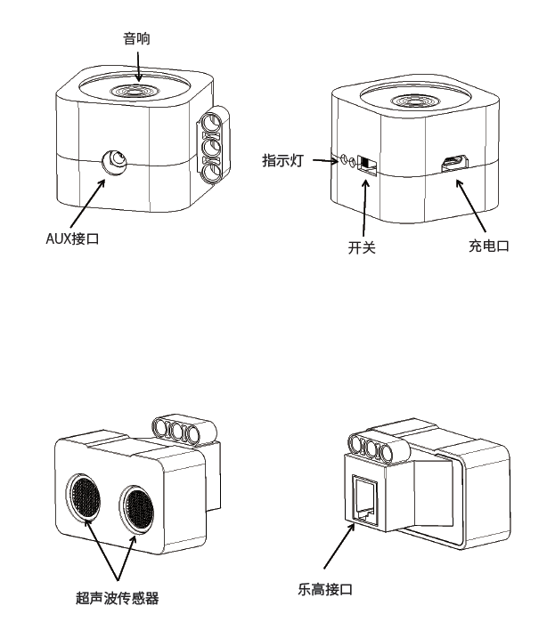

Lego Port

Ultrasonic Sensor

Charging Port

On/Off

Indicator Light

AUX Port

Speaker

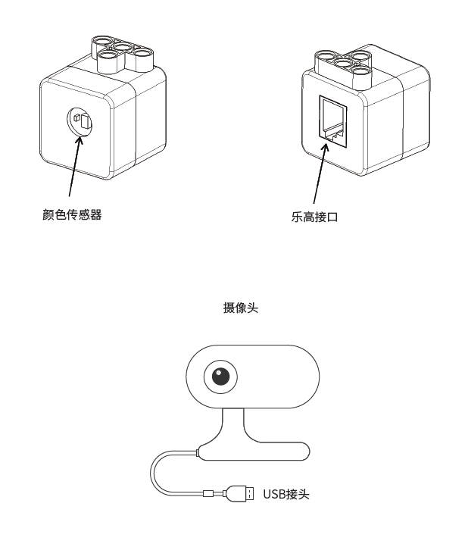

USB Port

Camera

Lego Port

Color Sensor

1.2 Product Regulations

|  |  |
| --- | --- |
|  | **Specifications** |
| FUNCTION | with Lego motor and building blocks for face recognition and gesture recognition, Human tracking and other artificial intelligence courses |
| SIZE | 92 × 62 × 73mm |
| CPU | Raspberry Pi 4, 2G |
| POWER SUPPLY | 3000mAh, 12V output |
| USAGE TIME | 2 hours |
| INTERFACE | USB × 4  HDMI × 1  DC power supply × 1  audio interface × 1  Lego crystal head interface × 8 (Can be connected to 4 motors, 4 sensors)  Gigabit Ethernet port × 1  micro USB × 1 (for Arduino firmware upgrade) |
| SENSOR | color sensor × 1 / ultrasonic sensor × 1 |
| MOTOR | uses Lego45544 + 45560 kit medium and large motor |
| MAIN CONTROL BUTTON | switch Button × 1  Function button × 1 |
| LED | RGB light × 2  Red and green double color light × 1 |
| CONNECTING CABLE | Micro USB 0.5m × 1  3.5 to 3.5 AUX audio cable 0.6m × 1 |

**2. How to Safely Operate SenseStorm**

Please read the following information carefully and know that SenseTime will not be responsible for liabilities including any direct or indirect damage caused by improper use.

1. Do not put your hands or any foreign objects on the air outlets of the upper and lower fans of the SenseStorm main control to avoid damage to the product due to overheating.
2. Do not use the Type C interface of the master to supply power to the master! Supplying power through this interface for a long time may cause circuit damage.
3. Mixed use with other types of batteries is prohibited. When the battery is about to run out, please charge it as soon as possible. At the same time, in order to prevent the battery from being over-discharged because of long-term unused, the battery should be charged regularly to maintain the power, and it is recommended to charge it once a month.
4. Please use the special adapter and cable that comes with the product for charging.
5. The normal working environment temperature of SenseStorm is 5-35℃, and the humidity is 20~60% RH. Please keep away from open flames and heat sources and avoid direct sunlight for a long time; do not cover the sensor, otherwise it will affect the normal operation of the sensor.
6. If SenseStorm does not operate normally, such as making unusual sounds, smells or smoke, please unplug the data cable, turn off the power supply and contact customer service immediately. All maintenance activities should be carried out under the guidance or supervision of technicians.

**3. Instruction Guidelines**

* 1. Software Installation

Please log onto <https://study.sensetime.com/download> to install the SenseStorm software tool.

* Download the **Robot Assistant Network Configuration Tool** on a mobile device for the control kit to connect to the designated network.
* Download the **SenseAgent Installation Package** on a computer for the PC-side educational robot to be connected to SenseStudy for tasks involving data transmission.
  1. Battery installation and charging
* The DC connector of the SenseStorm main control can supply power to the main control, and the usage time is about 2 hours. If SenseStorm is needed to be used for a long time, you can also directly connect the male connector of the power charger to the DC port of the main control board to maintain continuous power supply.

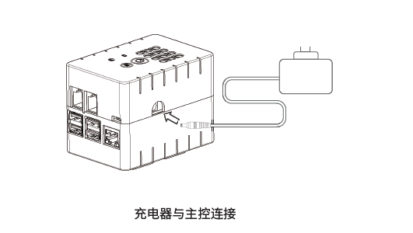

Connecting charger to Main Control Board

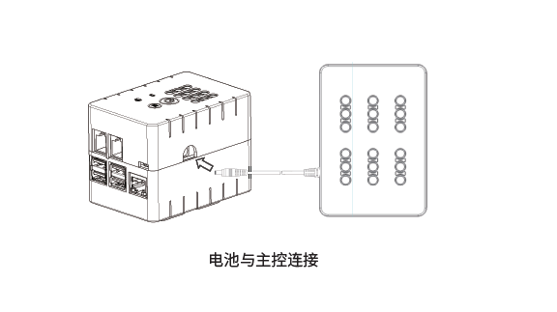

Connecting battery to Main Control Board

* The battery indicator on the main control of SenseStorm will indicate the battery level through changes in colors for the blinking lights.
* If the battery is fully charged, the battery indicator light turns green.
* When the battery is low, the battery indicator light turns red.   
  The buzzer will produce an alert tone when the battery is about to run out.
* It is recommended when the battery charge indicator lights red off as soon as possible. The charger can be inserted into the female head of the battery box to charge the battery. The indicator light on the power charger will indicate the charging status. When the indicator light on the charger is red, it means that it is charging; and when it is green, it means that the charging is complete.

**3.3.1 Sensor connection**

* Color sensors and ultrasonic sensors need to be connected to any port.
* In the experiment, you need to specify a specific port to obtain sensor data

**3.3.2 Motor connection and use**

* Motor can be connected to any port of AD
* In the experiment, you need to use the specified port to get the sensor data. The
* port also supports Lego's native large-scale motor and medium-sized motor.

**3.3.3 The connection and use of the audio**

* The provided charger is required for regular charging. When using the audio, please connect the audio cable to the audio port of the main control board and turn on the audio switch. Press and hold the power button on the SenseStorm main control for more than 2 seconds (the battery indicator light can be released, not more than 10s) to enter the power-on state: battery indicator light. The current battery status will be displayed. It takes about 40s to, and the mode indicator on the main controller lights up blue, and the boot is complete.
  1. **Shutdown**

Press and hold the power button on the SenseStorm main control board for 5 seconds, the battery indicator will turn off, and the shutdown is complete.

* 1. **Teaching Mode**

When the teaching mode is turned on, and the blue light will become apparent.

* After completing the network configuration, it enters the teaching mode by default, and the [Mode indicator] switches to the blue light state at this time.
* Connect the PC to the same LAN as SenseStorm and turn on SenseAgent.
* Log in to SenseStudy to open SenseStorm related course packages.
* Click "Connect Hardware" in the upper right corner, check the corresponding ID of the fuselage, find the corresponding SenseStorm, and click to connect.
* To examine the SenseStorm course package, enter the code in the code area. Press and click "Run" to see SenseStorm take corresponding actions.
  + 1. **Ball Tracking Mode**

Plug the camera into any USB port, and then long press the main control function button until the [mode indicator] turns yellow and release the button to switch to the ball tracking mode.

* Put the yellow ball in front of the camera, and SenseStorm will follow the movement of the ball.
  + 1. **Gesture Recognition Mode**
       1. Plug the camera into any USB port, then press and hold the main control function button until the [mode indicator] turns purple. Release the button to switch to gesture recognition mode.
* Place the SenseStorm model on the table, then face the camera while making the "V" sigh with your fingers. SenseStorm will then move in the direction of the hand gesture. Face the camera then make the "OK" hand gesture, and SenseStorm will move backwards in the same direction as your hands.
  + 1. **Face Detection Fan Mode.**
       1. In the gesture recognition mode, plug the camera into any USB port, then press and hold the function button until the [mode indicator] turns green.
* Import the SenseStorm model onto the desktop, face the camera, the SenseStorm fan will follow the direction of the face and adjust the wind speed according to the distance of the face: the closer the distance, the lower the wind speed.
  + 1. **Intelligent Network Configuration**

Plug the camera into any USB port, double-click the [function button], the [mode indicator] will flash in blue, and the voice prompt [Network Configured] will appear while entering the network configuration mode.

* Connect the mobile phone to an available LAN, open the mobile phone APP robot assistant, find SenseStorm, generate a QR code, and place the QR code in front of the SenseStorm camera. When the camera scans the QR code, a voice prompt will be displayed saying [Received network Information].
* **As shown below:**

|  |  |
| --- | --- |
| C:\Users\ADMINI~1\AppData\Local\Temp\WeChat Files\469d341a7c1ec1a685f417f51f841e1.jpg |  |
| After the mobile phone is connected to the WIFI | PC is connected to the same WIFI |

* The main control board will complete the network configuration, the voice will prompt the command [Connection Successful], and then the mode will return to the default teaching mode. The terminal will display "Connection Successful". If the network configuration fails or the timeout returns, the voice will prompt [Connection failed] and the mode will return to the network configuration mode. If you need to exit the network directly, press function button to switch back to the teaching mode.
* Note: LAN connection can only support 2.4G frequency
  1. **Key Operation and Quick LED indicator**
     1. Key Operation Correspondence Table

|  |  |  |
| --- | --- | --- |
| **Function** | **Mode** | **Instruction** |
| Power | On | Press main power button for 2 seconds |
| Power | Off | Press main power button for 5 seconds |
| Intelligent Distribution Network | Teaching mode | Double-click the function button |

**4. How to Clean SenseStorm**

* Do not use abrasives, aerosols, or any other liquid wiper because these contain flammable substances may damage the plastic packaging.
* Do not use water or other liquid spray to drench the fuselage.
* Please keep the sensor location clean and do not rub or cover the sensor.
* After power off, use a soft dry cloth to wipe the device clean.

**5. Common Errors and FAQ**

|  |  |
| --- | --- |
| **Common Error** | **Solutions** |
| After pressing the power button, the blue light does not light up. | (1) Check the power supply  (2) Check whether the TF card is inserted correctly |
| Mode switching is abnormal. | (1) Check whether the camera is connected  (2) Check whether the motor port has been correctly assembled |
| Failure to connect to sensor | (1) Check whether the cable is plugged in  (2) Check whether the port is correct. |
| Motor control fails | (1) Check whether the connection is plugged in  (2) Check whether the port is correct and there isis correct |
| No audio coming from speaker | (1) Check whether there is electricity  (2) Check whether the audio switch is turned on  (2) Whether the connection is stable |

